BASKETBALL COACHES

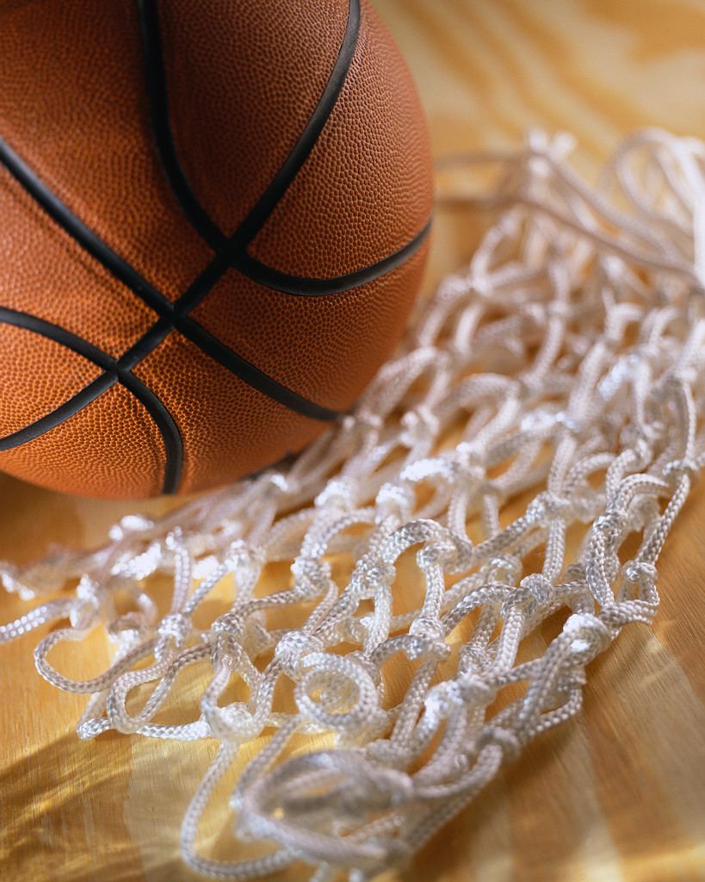

1200 W. Colton St.
Los Angeles, CA 90026
(On the corner of 1st & Beaudry Ave.)

Mandatory for a paid Basketball Coach to attend. If they cannot, then an Athletic Director or Assistant Principal/Athletics must attend. Thank you

